STEP 6 – WATER - CFS3 SDK tools SHP2POL, SHORELINE & WATER
6.0-) If you have shoreline and water shape files corrected (from STEP4), it is very easy to produce the required CFS3 files.
Shoreline file Water Shape file
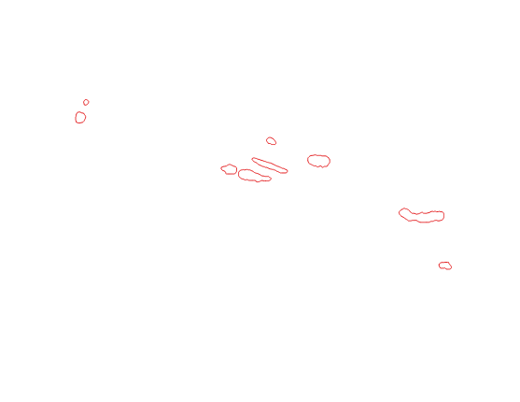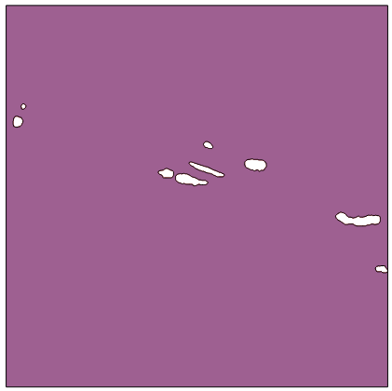
6.1-) First, convert SHP files to POL.
a-) Copy the files shoreline.* and water.* (indicated on image) to your make_water subdiretory.
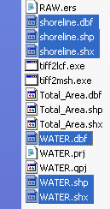
b-) Start your command line window and go to make_water subdir.
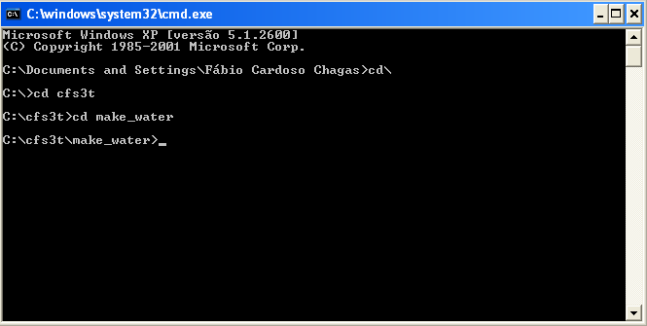
c-) Just use SHP2POL commands:
shp2pol shoreline.shp shoreline.pol 1 1
and
shp2pol water.shp water.pol 1 1
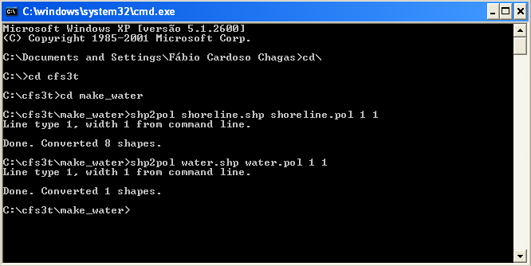
The POL files were generated
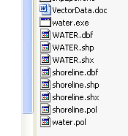

6.2-) For the next commands, you need to create a 2 new subdirs on make_water dir. Create a hyl and hyp subdirs.
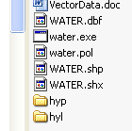
a-) For shoreline, use the following command with standard sdk parameters and boudind box coordinates (see CFS3_Math – Center of the theater –square limits in yellow). The generated files will be on hyl subdir.
shorelines 0.06125 hyl 3.5e-4 4.2e-3 1.0e-4 shoreline.pol -31.375 35 -25 41.375
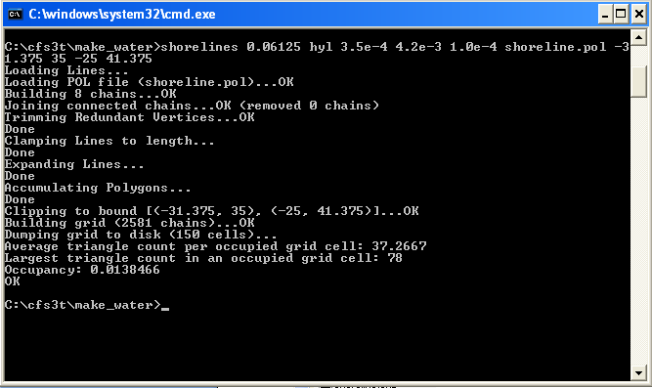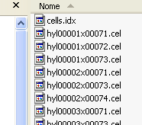

b-) For water shape, use the following command with standard sdk parameters and boudind box coordinates (see CFS3_Math – Center of the theater –square limits in yellow). The generated files will be on hyp subdir.
water 0.1107 1.0e-5 hyp -31.375 35 -25 41.375 water.pol
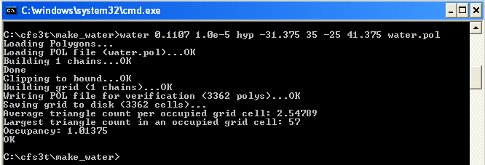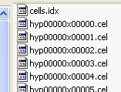

6.3-) END of STEP 6

